Chapter 12 Review

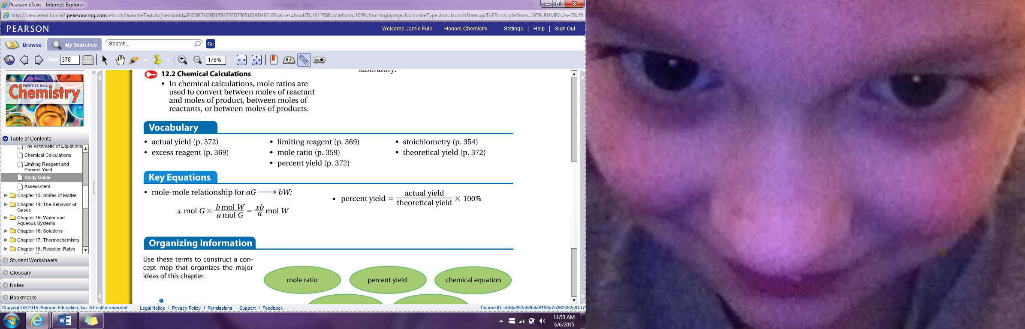

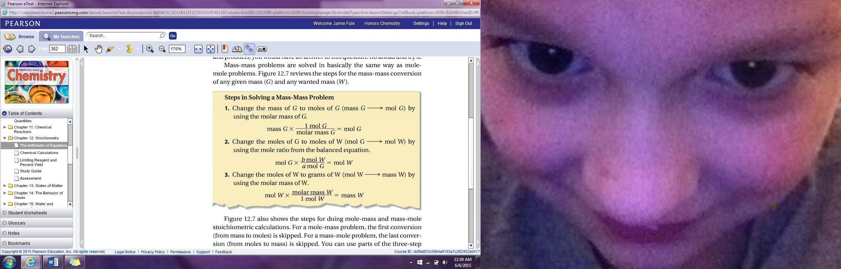

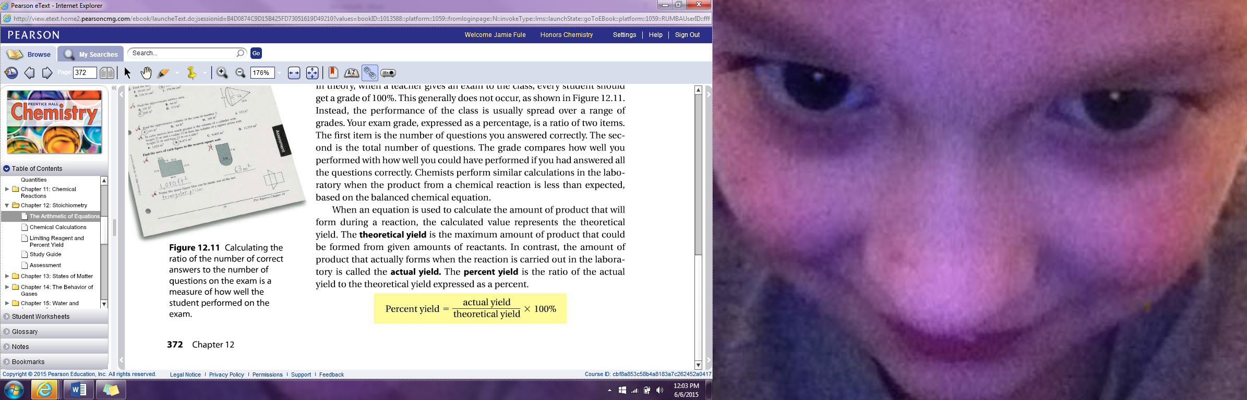

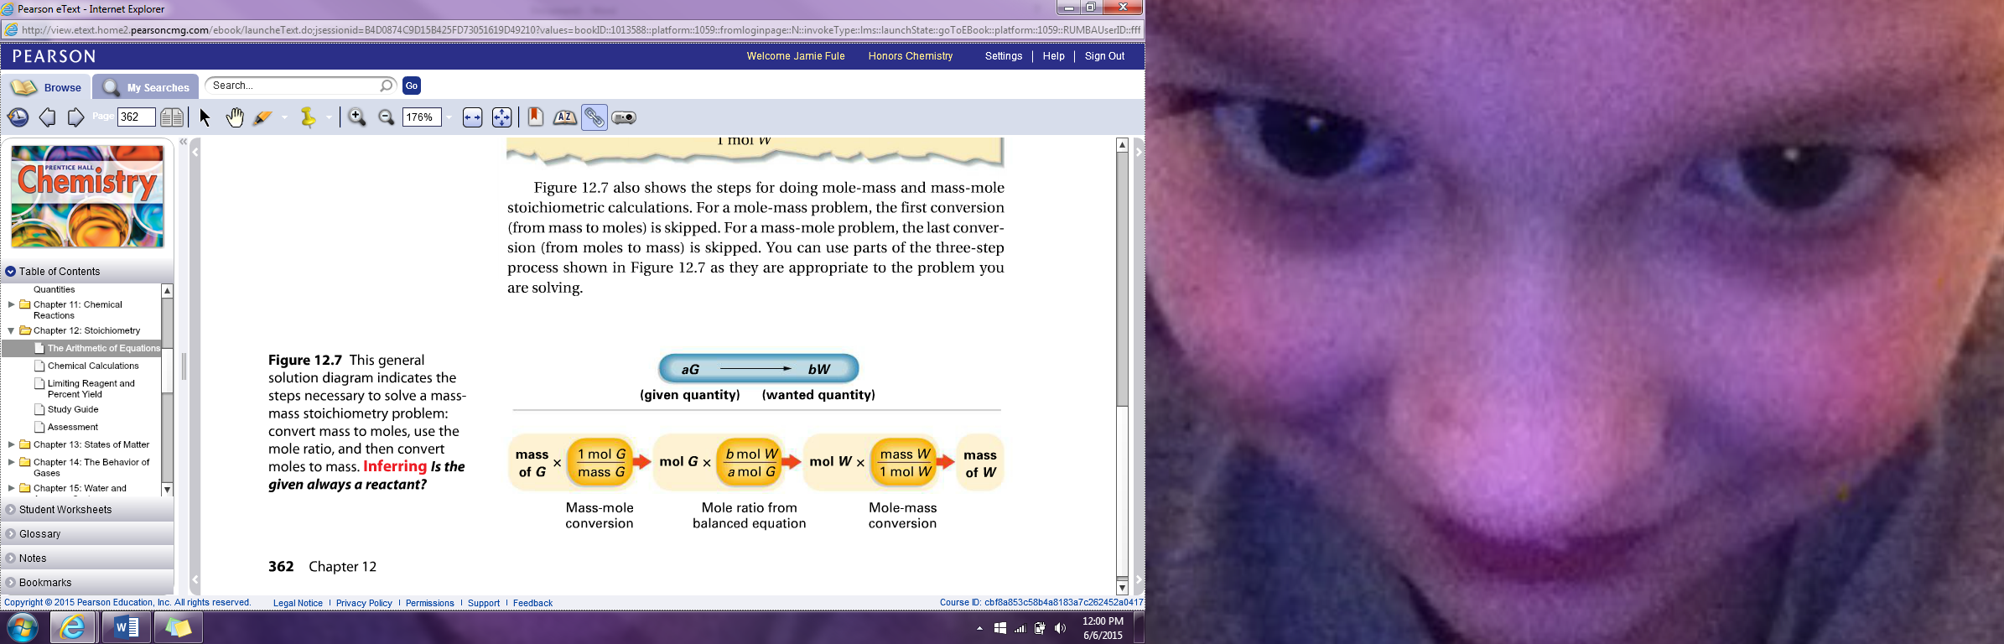

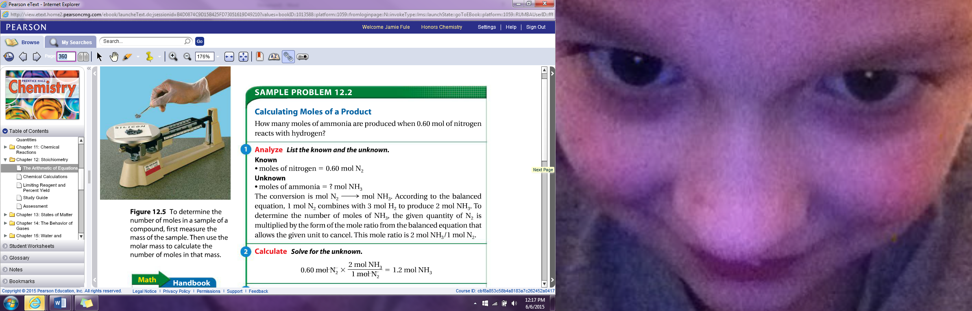

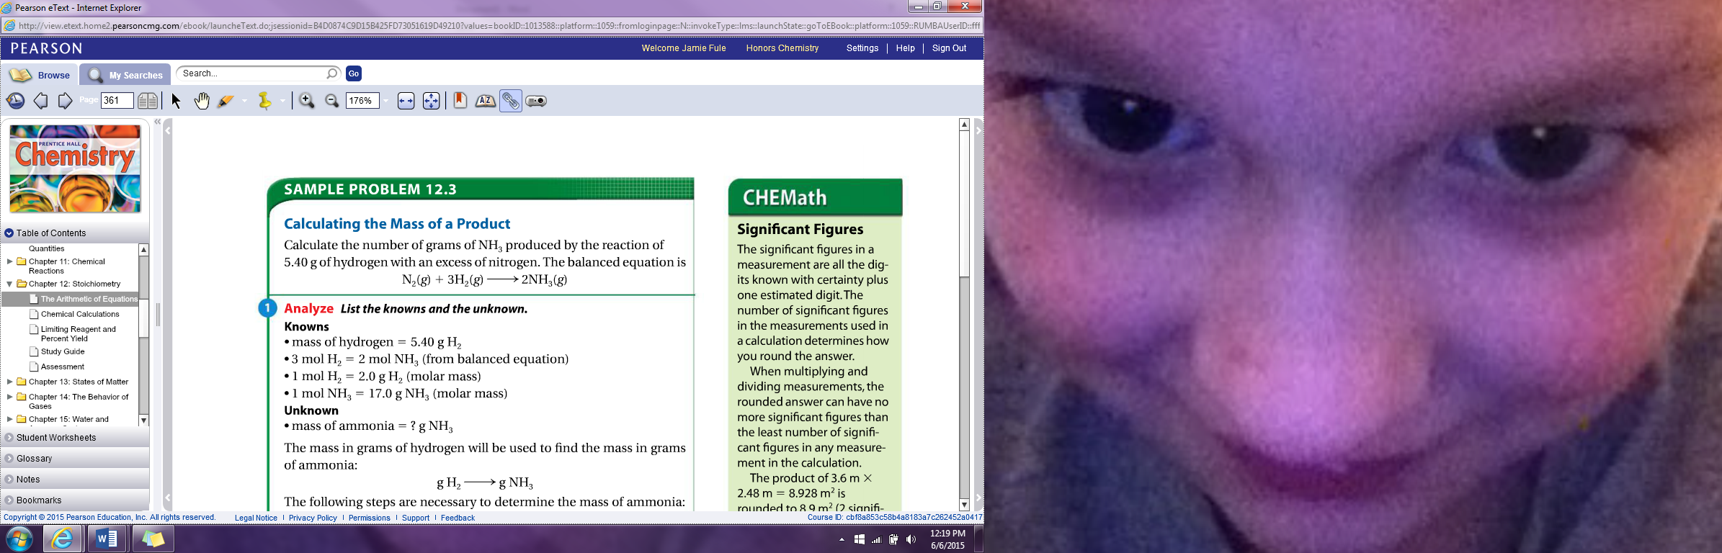

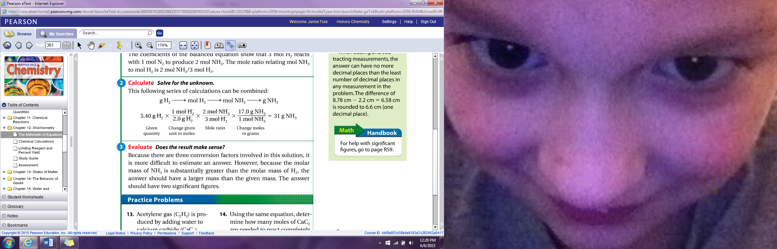

1. Define excess reagent:

The reactant that is not completely used up in a reaction

1. Define limiting reagent:

The reagent that determines the amount of product that can be formed by a reaction

1. Define theoretical yield:

Maximum amount of product that could be formed from given amounts of reactants

1. Define actual yield:

Amount of product that is actually forms when the reaction is carried out

1. Define percent yield:

Ratio of the actual yield to theoretical yield to the actual yield expressed as a percent

Chapter 14 Review

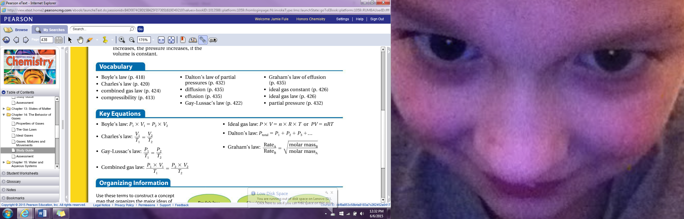

1. Define compressibility

Measure of how much the volume of matter decreases under pressure

1. Give 3 factors that affect gas pressure

The amount of gas, volume and temperature. Also if the temperature is constant as the pressure of gas increases the volume decreases

1. State Boyles Law

States that a given mass at constant temperature the volume of the gas varies inversely at constant temperature

1. State Charles’s law regarding temperature and volume

States that the volume of a fixed mass of gas is directly proportional to its kelvin temperature if the pressure is kept constant. Also, as the temperature of an enclosed gas increases, so does the volume only is the pressure remains constant

1. State Gay-Lussac’s law

States that the pressure of a gas is directly proportional to the kelvin temperature if the volume remains constant. Also, as the temperature of an enclosed gas increases the pressure increases if the volume is constant

1. State the ideal gas constant

The ideal gas constant is 8.31

1. State Dalton’s law regarding partial pressure

States that at constant volume and temperature the total pressure exerted by a mixture of gases is equal to the sum of the partial pressure of the component gases

1. State Graham’s Law

States that the rate of effusion of a gas is inversely proportional to the square root of the gas’s molar mass

1. Define diffusion

Tendency of molecules to move toward areas of lower concentration until the concentration is uniform throughout

1. Define effusion:

The process in which a gas escapes through a tiny hole in the container

Chapter 16 Review

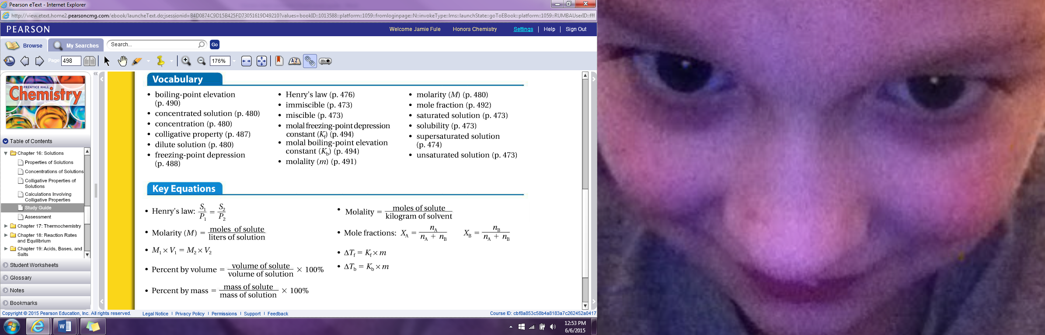

1. Give 3 factors that determine how fast a substance will dissolve

Stirring (agitation), temperature and the surface area of a substance. If something is stirred it will dissolve quicker. If the temperature of something is raised it will dissolve quicker and if the temperature is lower it won’t dissolve as quickly and the smaller the particle size equals more surface area exposed equals faster dissolving time

1. Define the 3 types of solutions - Supersaturated, Saturated and unsaturated

Supersaturated: contains more solute than it can theoretically hold

Saturated: contains the maximum amount of solute for a given amount of solvent at constant temperature and pressure

Unsaturated: Contains less solute than a saturated solution

1. Define solubility

Amount of solute that dissolves in a given amount of a solvent at a specified temp and pressure

1. Define miscible

If 2 liquids dissolve in each other in all proportions

1. Define immiscible

Liquids that can’t dissolve in each other

1. State Henry’s Law

States that at a given temperature, the solubility of a gas in a liquid is directly proportional to the pressure of a gas above the liquid

1. Define concentration:

The concentration of a solution is a measure of the amount of solute that is dissolved in a given quantity of solvent

1. Define dilute solution

Contains a small amount of solute

1. Define a concentrated solution

Contains a large amount of solute

1. Define molarity and how to solve for it

Number of moles of solute dissolved in one liter of solution and to calculate molarity divide moles of a solute by the volume of a solution

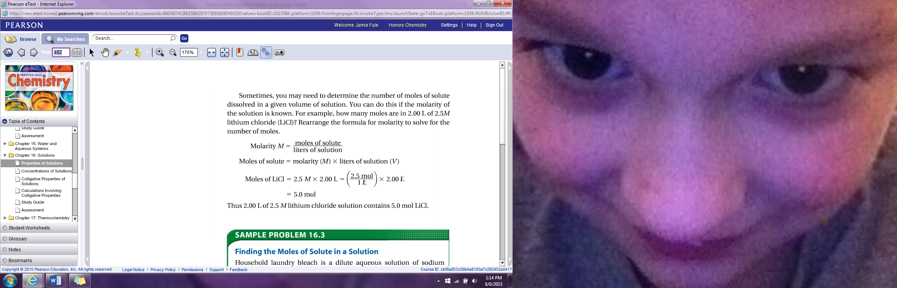

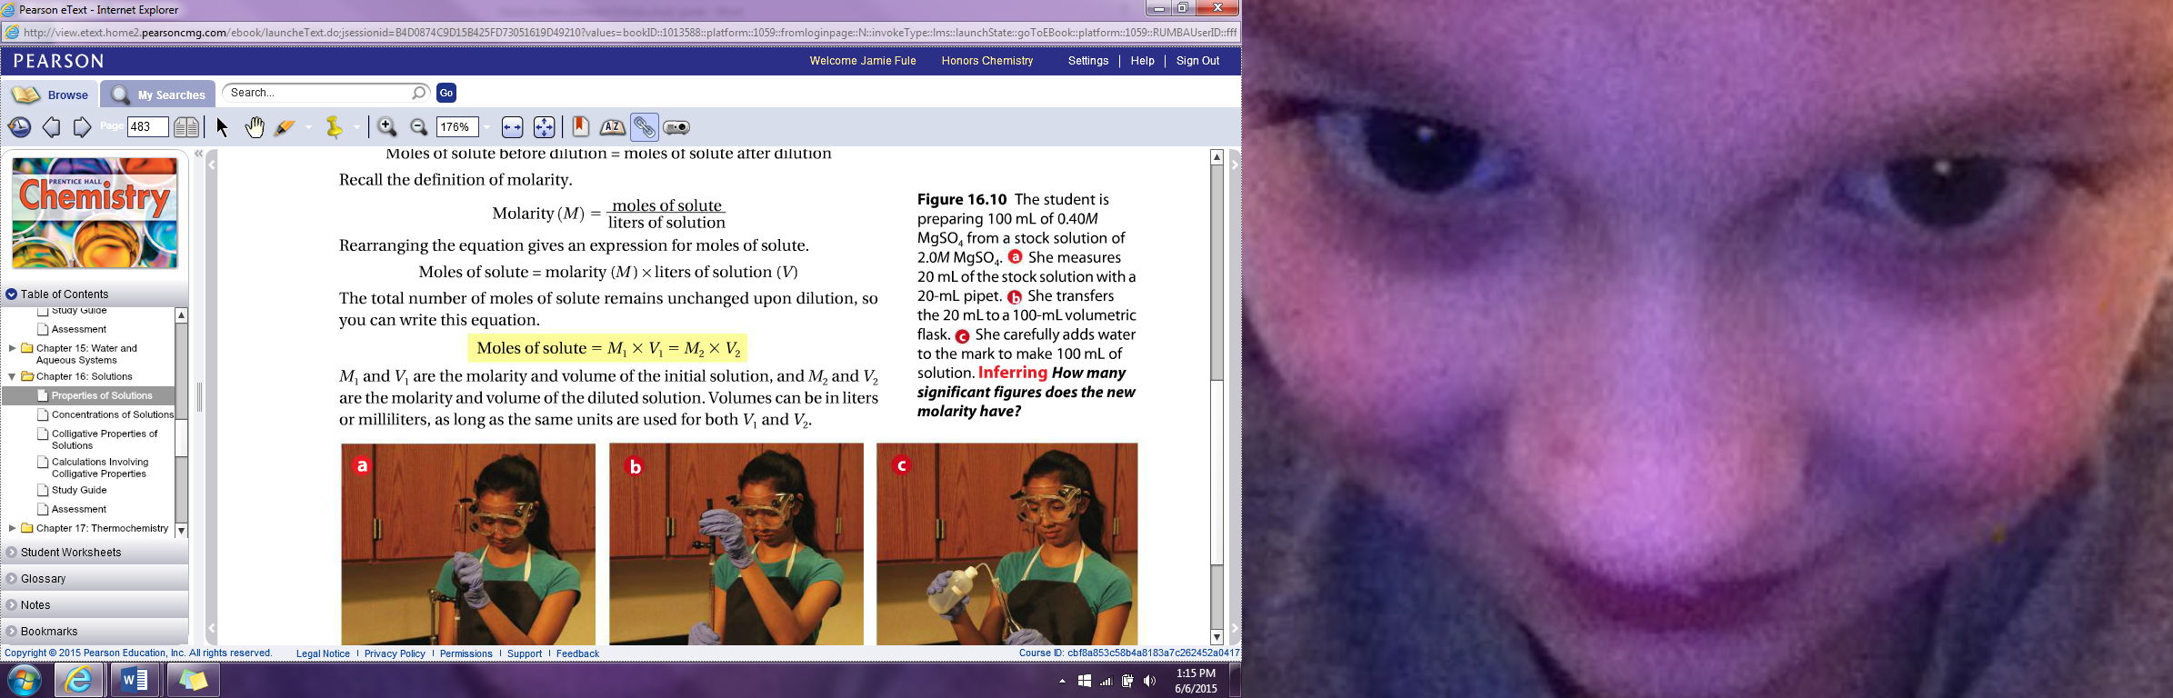



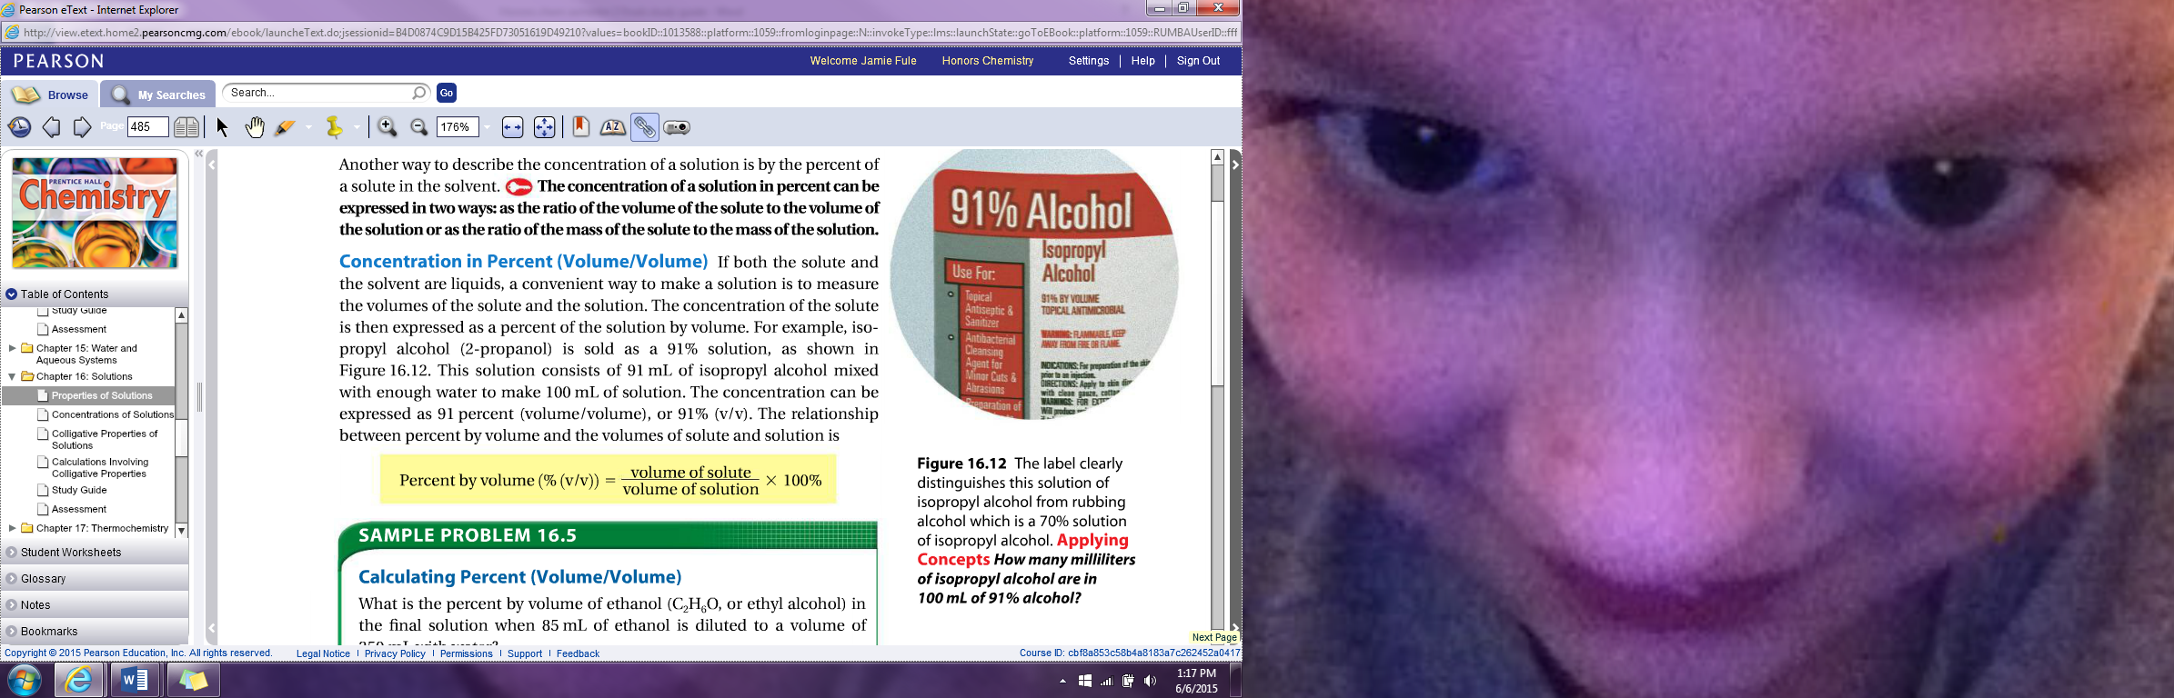

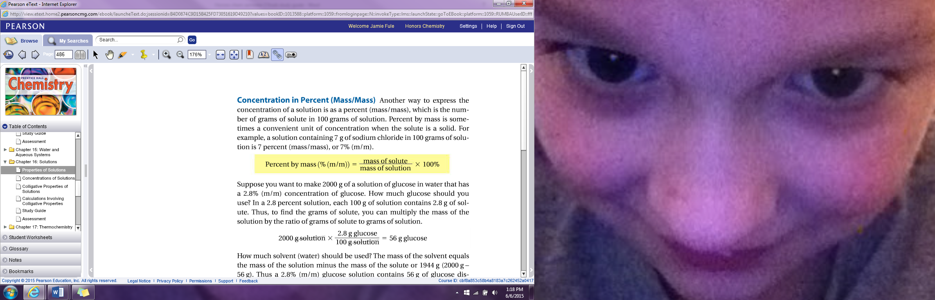

1. Define colligative properties and give 3 examples

A property that depends only upon the number of solute particles and nt upon their and identity. Three examples would include vapor-pressure lowering, boiling point elevation and freezing-point depression

1. Define vapor pressure lowering

The decrease in a solution’s vapor pressure is proportional to the number of particles the solute makes in a solution

1. Define freezing point depression

The difference in temperature between the freezing point of a solution and the freezing point of the pure solvent

1. Define boiling point elevation

Difference in temperature between the boiling point of a solution and the boiling point of a pure solvent

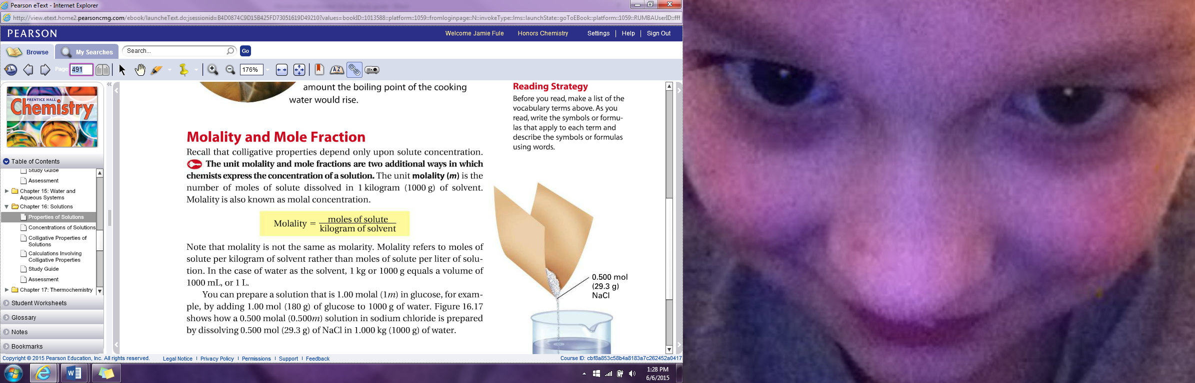

Chapter 17 Review

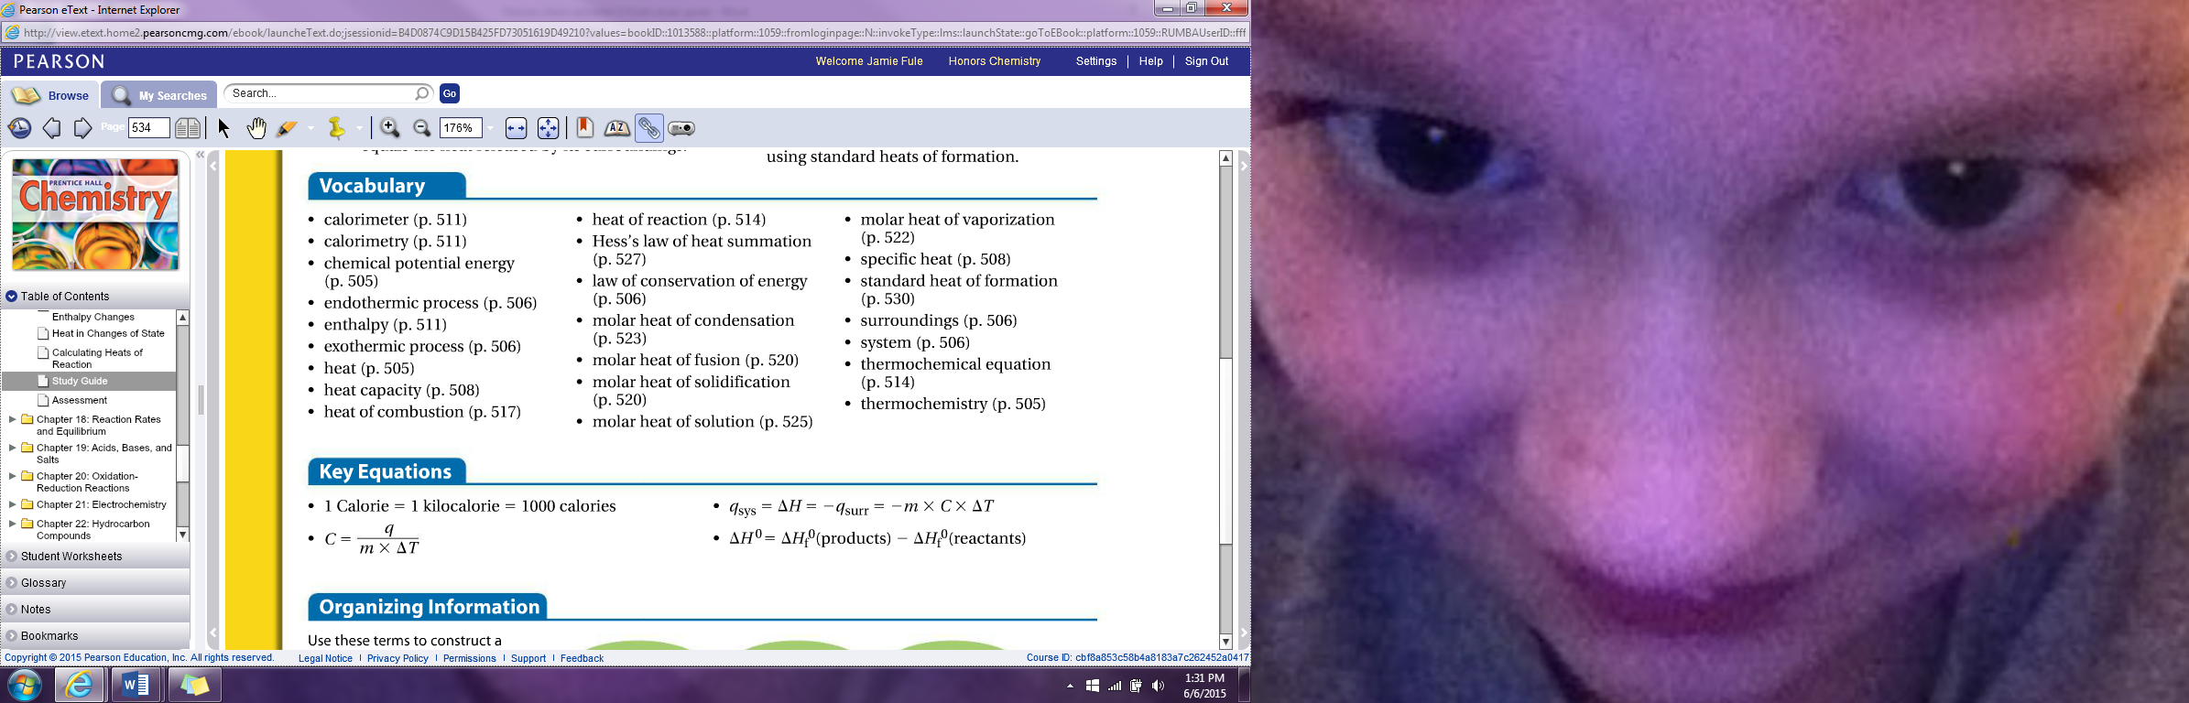

1. Define Thermochemistry

Study of energy changes that occur during chemical reactions and changes in state

1. Define Chemical potential energy

Energy stored in the chemical bonds of a substance

1. Define heat

Energy that transfers from one object to another because of a temperature difference. Heat flows from a warmer object to a cooler object

1. The difference between system and surroundings

The system is the part of the universe on which you focus your attention while the surroundings include everything else in the universe

1. State the Law of Conservation of Energy

States that energy is never created or destroyed in any chemical process

1. Define and explain an endothermic process

Process in which it absorbs heat from surrounding. In an endothermic process the system gains heat as the surroundings cool down. This is defined as positive because it is gaining heat

1. Define and explain an exothermic process

One that releases heat to its surroundings. In an exothermic process the system loses heat as the surroundings heat up. This is defined as negative because it is losing heat

1. What are the 2 units heat is measured in

The calorie and the joule

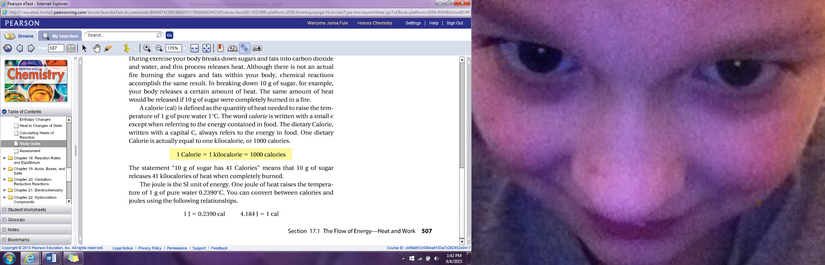

1. Define calorie

Quantity of heat needed to raise the temperature of 1 gram of pure water 1 degree Celsius

1. Define Joule

SI Unit of energy which raises the temperature of 1 gram of water 0.2390 degrees Celsius

1 Joule= 0.2390 calorie 4.184 Joules= 1 calorie

1. Define heat capacity

Amount of heat needed to increase the temperature of an object 1 degree Celsius. The heat capacity of an object depends on its mass and chemical composition

1. Define specific heat

Amount of heat it takes to raise the temperature of 1 g of the substance 1 degree Celsius. The specific heat of water 1.00.

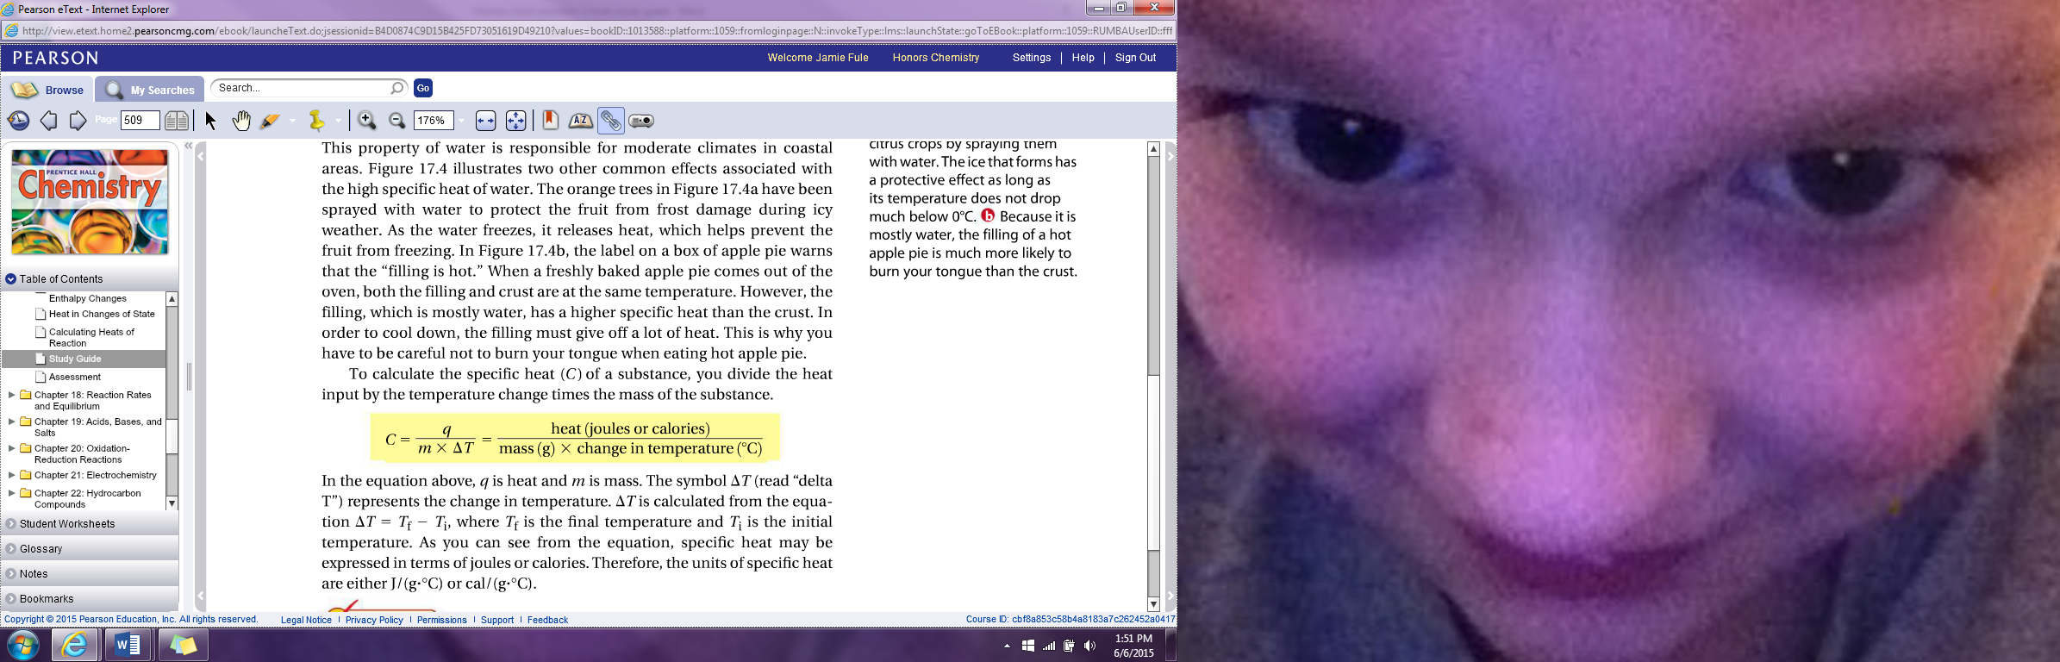Specific heat equation



1. Define calorimetry

Precise measurement of the heat flow into or out of a system for chemical and physical processes. In calorimetry the heat released by the system is equal to the heat absorbed by its surroundings

1. Define calorimeter

Insulated device used to measure the absorption or release of heat in a chemical or physical process

1. Define enthalpy

Heat content of a system at constant pressure

Heat of systems equation: 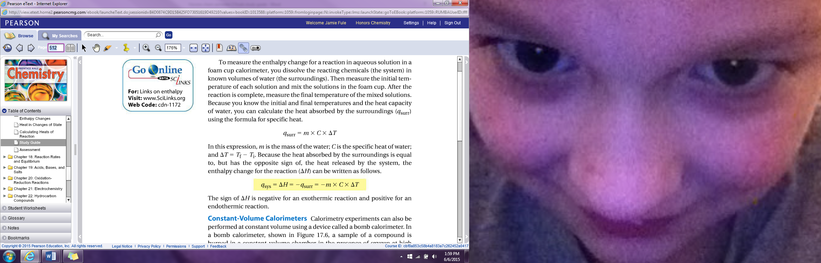

Heat of surroundings equations: 

1. Define thermochemical equations

A chemical equation that includes enthalpy change

Ex.

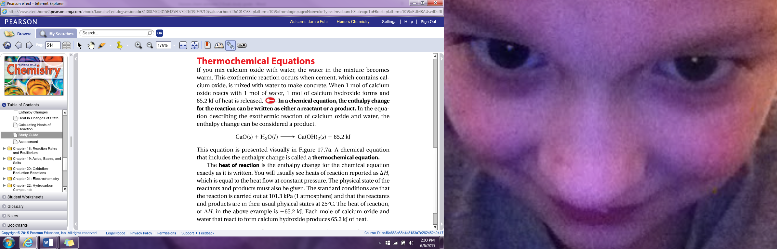

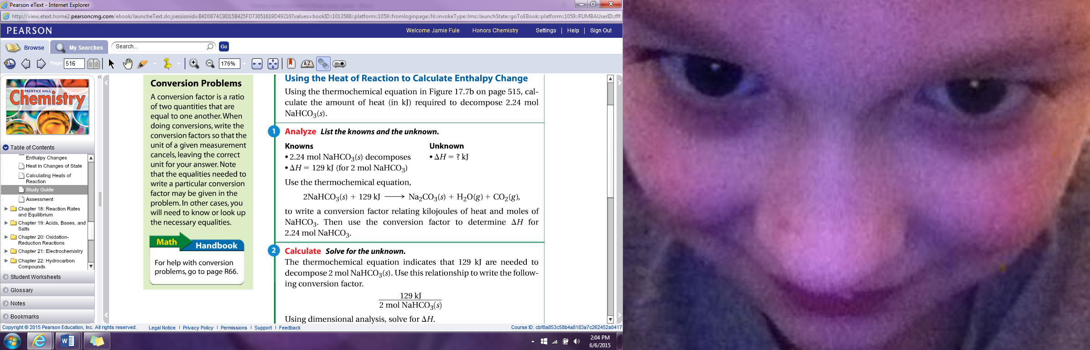

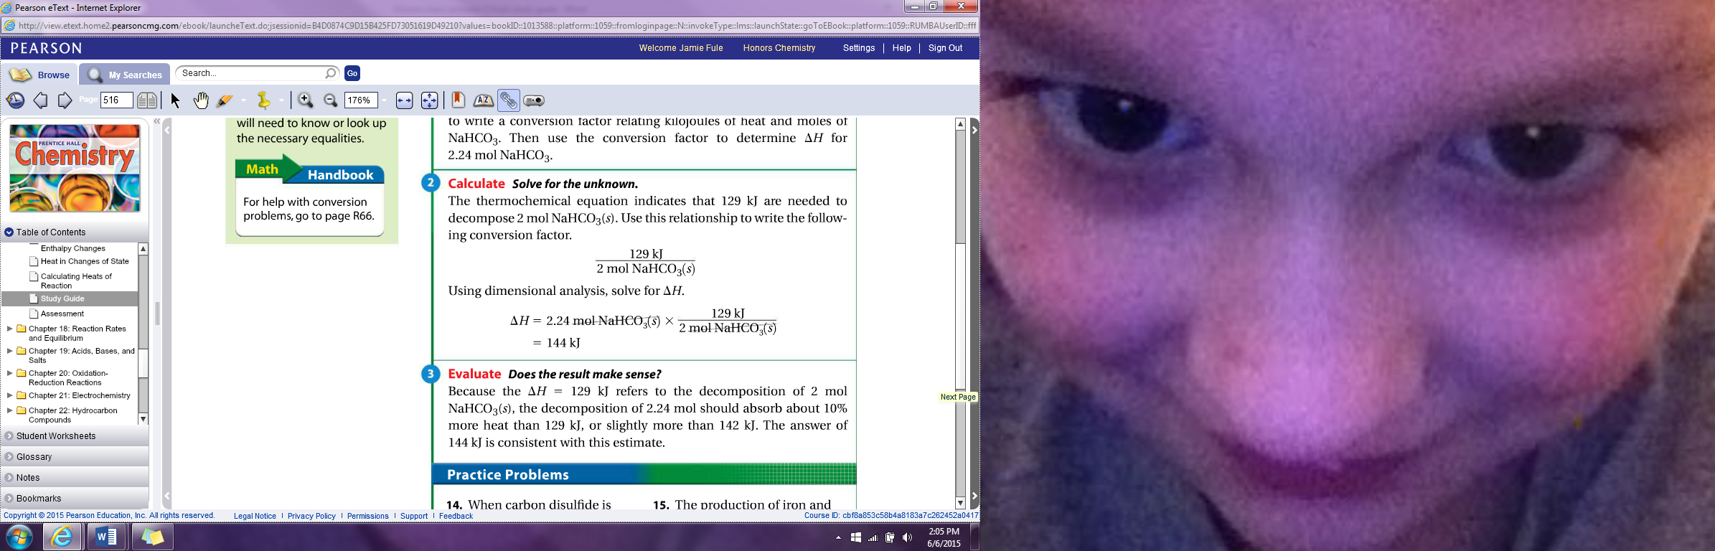

1. Define heat of combustion

Heat of reaction for the complete burning of mole of a substance

1. Define molar heat of fusion

The heat absorbed by one mole of a solid substance as it melt to a liquid at a constant temp

1. Define molar heat of solidification

The heat lost when one mole of a liquid solidifies at a constant temperature

1. Define molar heat of vaporization

Amount of heat necessary to vaporize one mole of a given liquid

1. Define molar heat of condensation

Amount of heat released when one mole of vapor condenses at the normal boiling point

1. Define molar heat of a solution

Enthalpy change caused by dissolution of one mole of a substance

1. State Hess’s law of heat summation

States that if you add two or more thermochemical equations to give a final equation then you can also add the heats of reaction to give the final heat of reaction. Hess’s law allows you to determine the heat of reaction indirectly

1. Define standard heat of reaction

Change in enthalpy that accompanies the formation of one mole of a compound from its elements with all substances in their standard states at 25 degrees Celsius

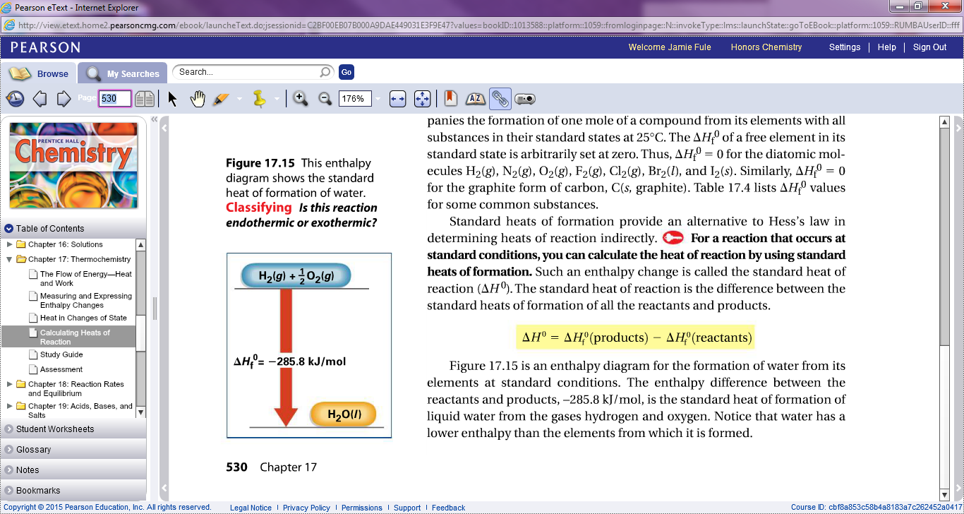

Chapter 18 Review

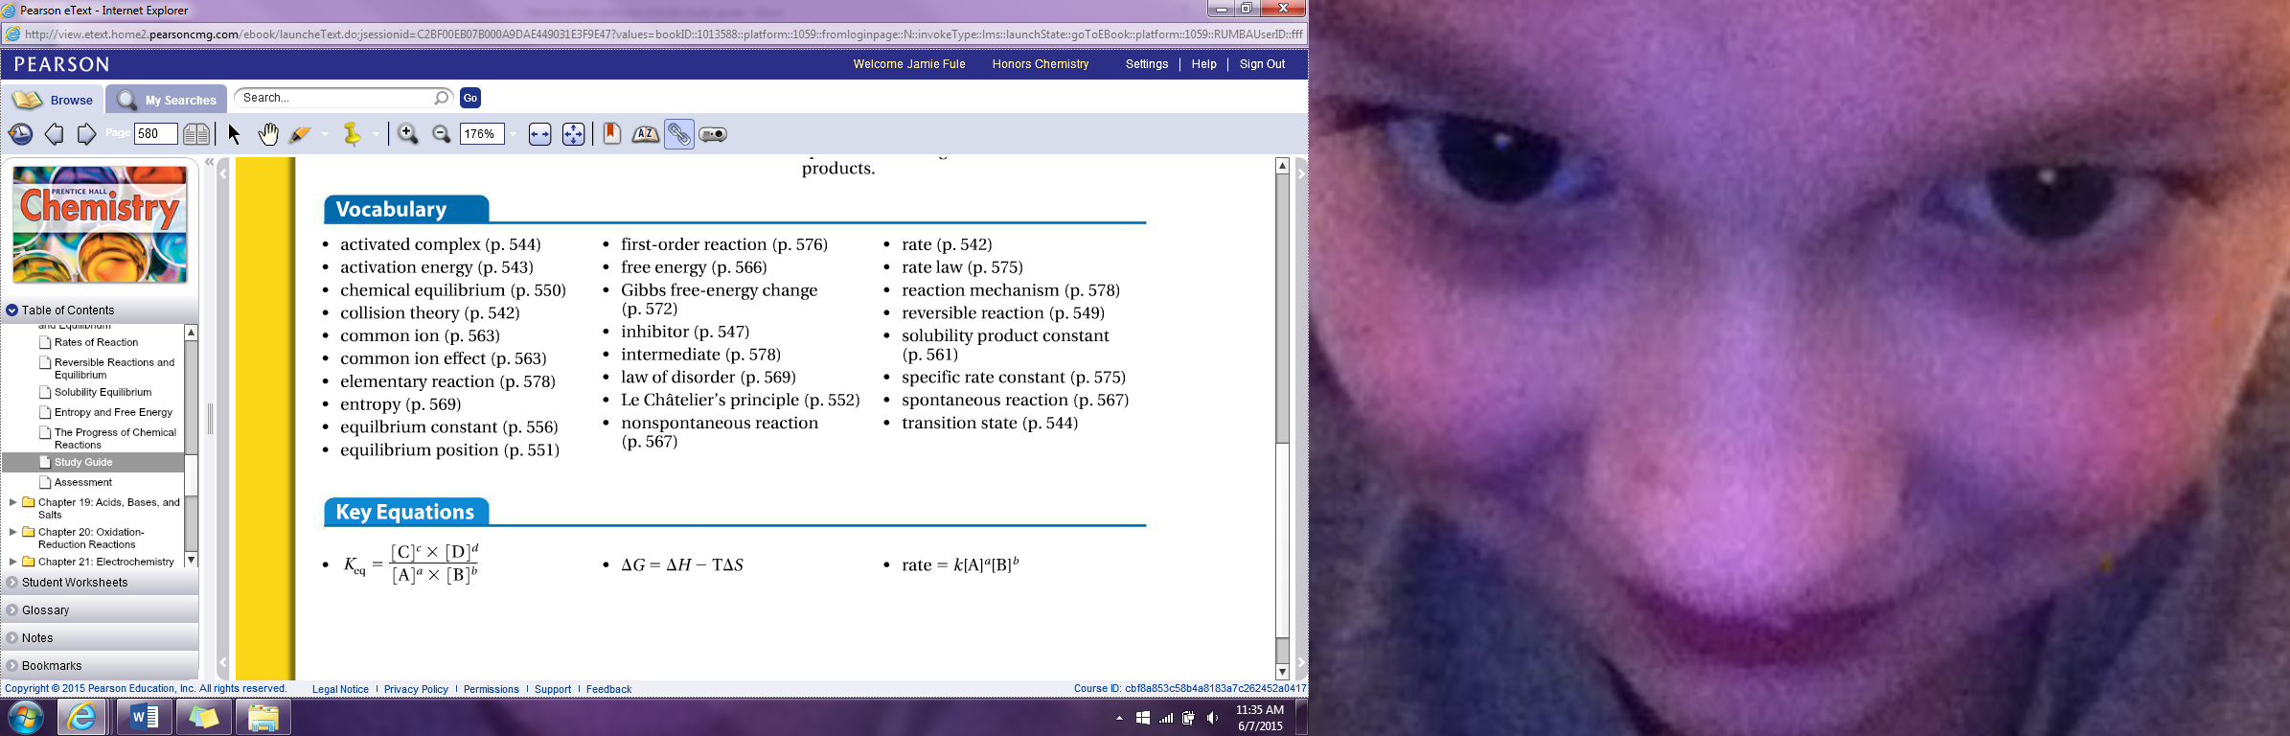

1. Define rate

Is the measure of the speed of any change that occurs within an interval of time

1. State the Collision Theory

Atoms, ions, and molecules can react to form products when they collide with one another

1. Define activation energy

Minimum energy that colliding particles must have in order to react

1. List and define 4 factors that affect reaction rate

Temperature: Raise in temp speeds up reaction

Concentration: Higher concentration equals higher reaction rate

Particle Size: The smaller the particle equals more surface area exposed which equals an increase in reaction rate

Catalysts: Increases reaction rate but is not used up in reaction

1. Define a reversible reaction

A reaction in which the conversion of the reactants to products and vice versa occur simultaneously

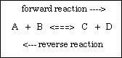

1. Define chemical equilibrium

When the rates of the forward and reverse reactions are equal. At chemical equilibrium, no net change occurs in the actual amounts of the components of the system

1. State Le Chateliers principle

It states that if a stress is applied to a system the system changes in a way that relieves that stress. Stresses that upset the equilibrium of a chemical system include changes in the concentration of reactants or products, changes in temperature and pressure

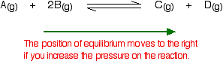

1. Define equilibrium constant and the equation

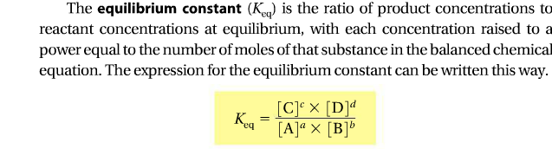

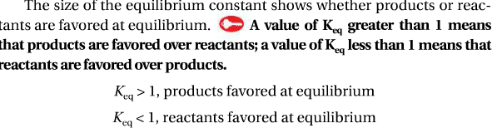

Chapter 19

1. Give properties of acids

Taste sour and produce H+ ions

1. Give properties of bases

Taste bitter, feel slippery and produce OH- ions

1. Give the three theories pertaining acids and bases

|  |  |  |
| --- | --- | --- |
| Arrhenius | Bronsted-Lowry | Lewis Acids and Bases |
| Acids: hydrogen compounds ionize to yield hydrogen ions(H+)  Bases: Hydroxide compounds ionizes to produce hydroxide ions (-OH)  Arrhenius Acids:  Monoprotic: contain one ionizable hydrogen ion  Diprotic: contain two ionizable hydrogen ions  Triprotic: Contain three ionizable hydrogen ions | -Defines an acid as a hydrogen-ion donor and a base as a hydrogen-ion acceptor  Conjugate acid: particle formed when a base gains a hydrogen ion  Amphoteric: a substance that can be both an acid and a base (ex. Water) | -An acid accepts a pair of electrons during a reaction while a base donates a pair of electrons |

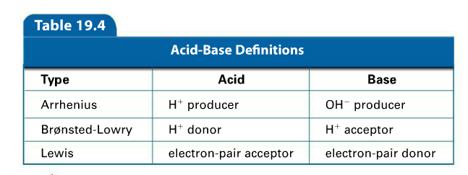

1. Define self ionization

Reaction in which water molecules produce ions

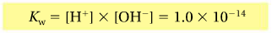Constant for water

A acidic solution: when H+ ions is greater than OH-

A basic solution: when H+ ions are less than OH- AKA Alkaline solutions

How to find Ph:

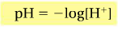

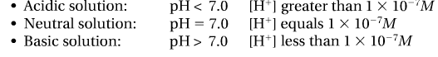

How to calculate POH:

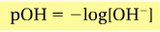

1. What do neutralization reactions produce?

A salt and water

1. Define titration

Process of adding a known amount of solution of known concentration to determine the concentration of another solution

1. Define standard solution

The solution of known concentration

1. Define end point

Point at which the indicator changes color. The point of neutralization is the end point.